Ysgol Gymraeg y Cwm
“Gwnewch y pethau bychain”
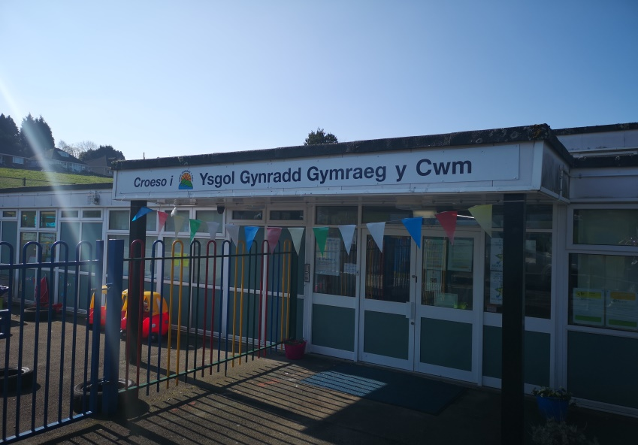

Croeso i’r Cyfnod Sylfaen!


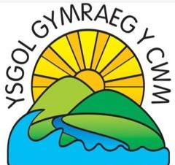
Annwyl Riant/Warcheidwad,
Croeso cynnes iawn i chi a’ch plentyn i Ysgol Gymraeg y Cwm. Edrychwn ymlaen at gydweithio gyda chi ac i feithrin perthynas gyda chi a’ch plentyn.
Paratowyd y llyfryn hwn yn arbennig ar eich cyfer. Cewch wybodaeth ddefnyddiol, cyngor a manylion cyswllt hefyd.
Cysylltwch â ni os bydd unrhyw gwestiynau, edrychwch ar ein gwefan a chofiwch ddilyn ni ar Drydar.
Mrs R-W Davies – Arweinydd y Cyfnod Sylfaen
Dear Parent/Guardian,
A warm welcome to you and your child to Ysgol Gymraeg y Cwm. We look forward to working with you and nurturing a positive relationship with you and your child.
We have prepared this booklet for you especially. You will find useful information advice and our contact details.
Please do not hesitate in contacting us with any questions, visit our website and remember to follow us on Twitter.
Mrs R-W Davies – Foundation Phase Leader
E-bost/E-mail : ygycwm@swansea-edunet.gov.uk
Cyferiad/Address
Ysgol Gymraeg y Cwm
Mansel Road / Jersey Road
Bonymaen
Swansea
SA1 7DL
Tel: 01792 650326
http://www.ygycwm.co.uk/
Twitter: @ysgolycwm
Pennaeth/Headteacher : Mrs S David
Paratoi eich plentyn ar gyfer y Meithrin
Siaradwch yn gadarnhaol am Ysgol gyda’ch plentyn. Darllenwch lyfrau am ei hoff gymeriadau yn dechrau ysgol. Manteisiwch ar y cyfleodd i’ch plentyn gymysgu gyda phlant yr un oedran drwy gyfrwng y Gymraeg yn lleol.
Ceisiwch annog eich plentyn i fod yn annibynnol wrth:
- Fynd i’r tŷ bach
- Golchi ei ddwylo/dwylo
- Adnabod, gwisgo a dad-wisgo ei chot/got
- Rhannu a thacluso teganau
- Adnabod ei enw/henw

‘Mae addysg yn dechrau yn y cartref’ www.dysgu.cymru.org.uk
Preparing your child for Nursery
Speak positively to your child about starting school. Share books about their favourite character starting school. Take advantage of opportunities to socialise your child with children of the same age and socialise through the medium of Welsh.
Encourage and support your child to be independent:
- Going to the toilet
- Washing their hands
- Recognise, wear and remove their coat
- Share and tidy away toys
- Recognise their name

‘Education begins at home’ www.learning.wales.gov.uk
Sesiwn Meithrin / Nursery Session
Am: 8:50-11:20am

Clwb brecwast/Breakfast club FREE
Every day: 8:20-8:40am

Amser ffrwyth a llaeth / Fruit and Milk
Mae llaeth (neu dŵr) ar gael am ddim i’ch plentyn bob dydd.
Dewch a ffrwyth ar gyfer amser snac.
Milk (or water) available daily for all children.
Please provide your child with fruit for snack time.


Gwybodaeth defnyddiol / Useful Information
Athrawes y Dosbarth Meithrin ydy: Mrs R Davies
Nursery class Teacher: Mrs R Davies
Athrawes y Dosbarth Derbyn ydy Miss K Squire
Reception class teacher Miss K Squire

Nursery Support Assistants: Miss Pritchard & Mrs Jones

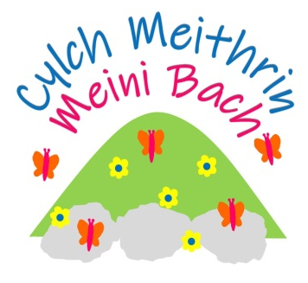
Clwb ar ôl ysgol ar gael/After school club available
Cylch Meithrin Meini Bach - Cynnig gofal 30 awr, gofal cofleidiol, dydd a sesiynau Cylch (oed 2-4)
30 hours free childcare, wrap around, Cylch sessions and day care
Contact/Cysylltwch â Mari: 07395 136474

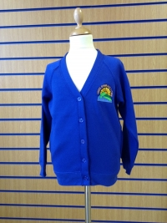
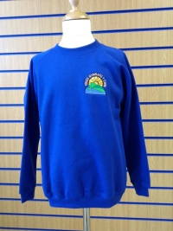
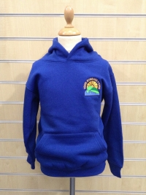
Gwisg Ysgol
Cewch wybodaeth llawn am ofynion ac am sut i archebu gwisg ysgol swyddogol y’r ysgol ar dudalen 22 ein prosbectws ysgol a gwefan ein hysgol.

Cofiwch! Dodwch enw eich plentyn ar bob ddiledyn! School Uniform
Please refer to page 22 of our Prospectus for full details regarding school uniform requirements and where it can be purchased. Alternatively, information can be obtained on our school website.
Remember! Please put your child’s name on every item of clothing!
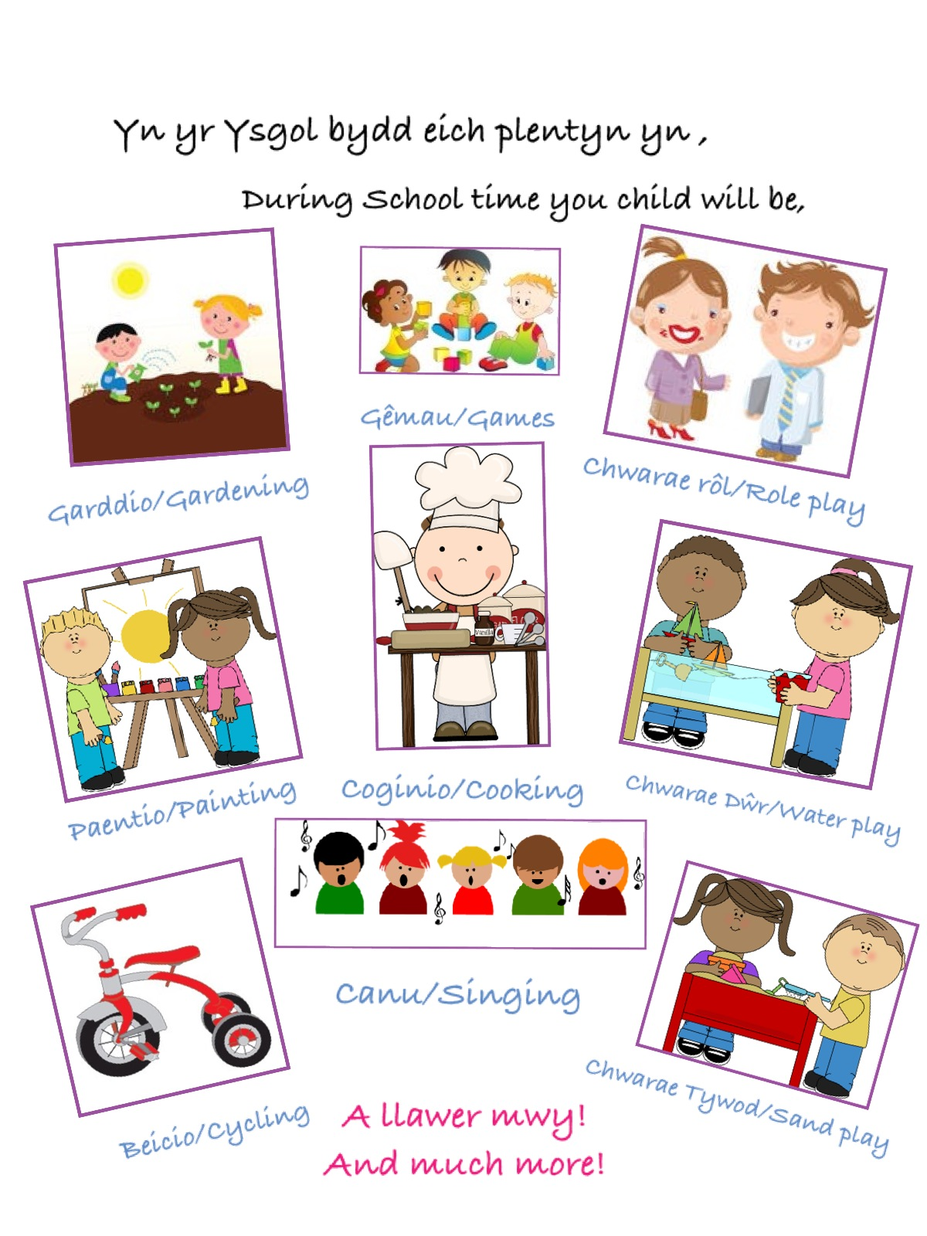
Bydd …….……. yn dechrau’r dosbarth Meithrin yn Ysgol Gymraeg y Cwm ar …………………….am ……………

……........will be starting Nursery class at Ysgol Gymraeg y Cwm on ……………………… at ……………
(Please contact the school for this information)


